Sprint Visual Summary Document
Tristian — Writing Code
Tristian focused on advancing his feature work this sprint, closing out key tickets and resolving several blockers that had been slowing progress. He also supported the team by reviewing PRs and helping refine requirements for upcoming tasks.
He did not complete any stories
product list page, display product info, add to cart buttons, display out of stock
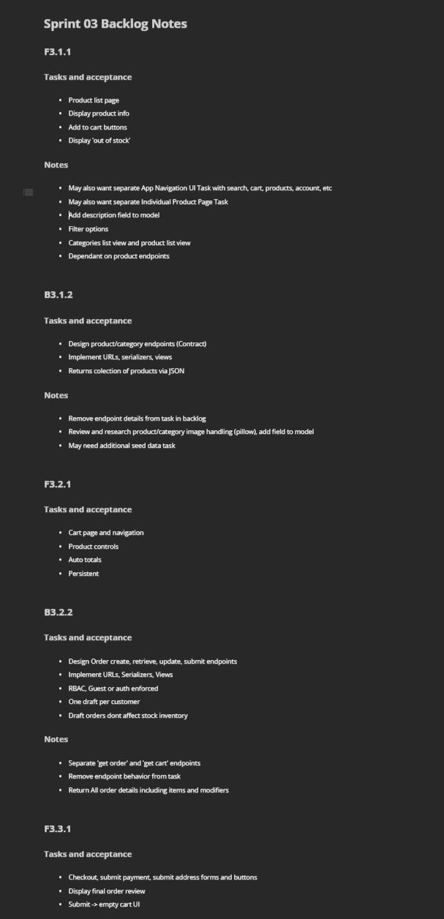He did not complete any stories
• Screenshot(s):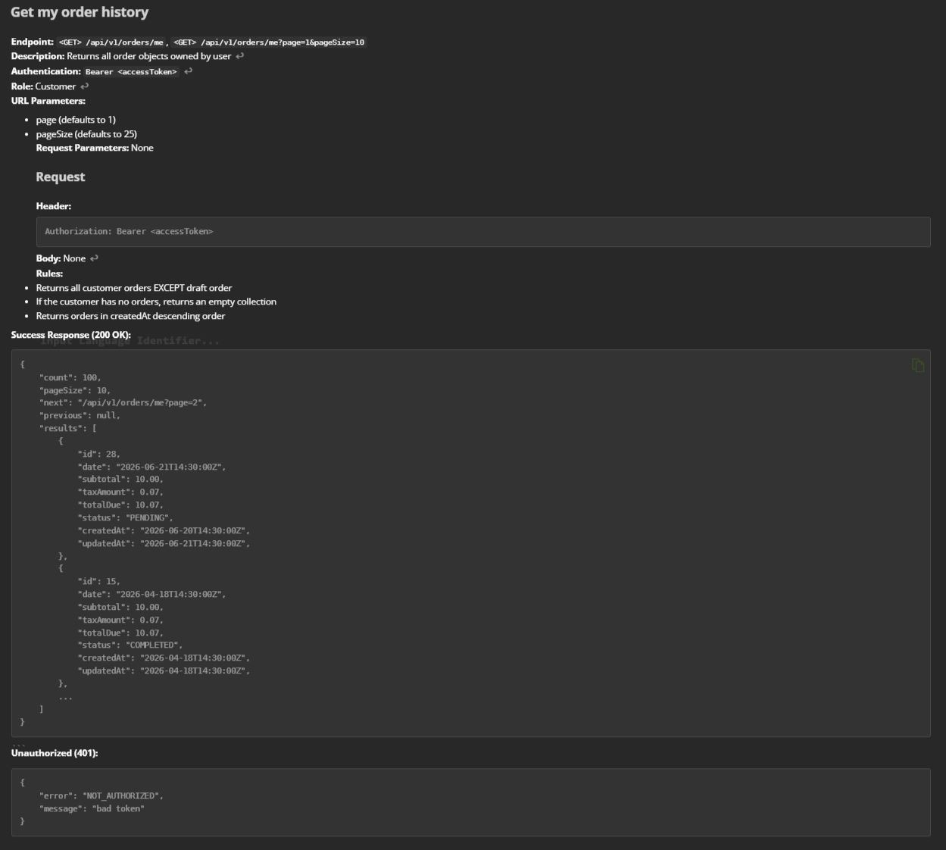
Kenny — Testing Code
Kenny spent this sprint driving progress on his core feature work, wrapping up several in‑flight tasks and clearing blockers that had been slowing momentum. He also contributed to team stability by reviewing PRs and coordinating on upcoming requirements.
He did not complete any stories
Sprint 3 Testing Matrix, Test Coverage Matrix, Execution Status Summary, Sprint 3 Test Cases
Screenshots
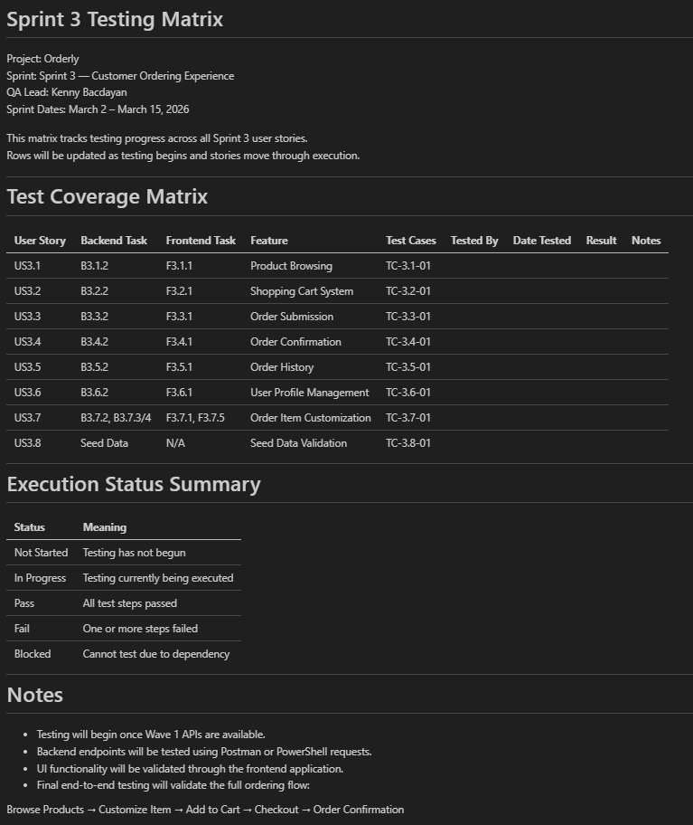
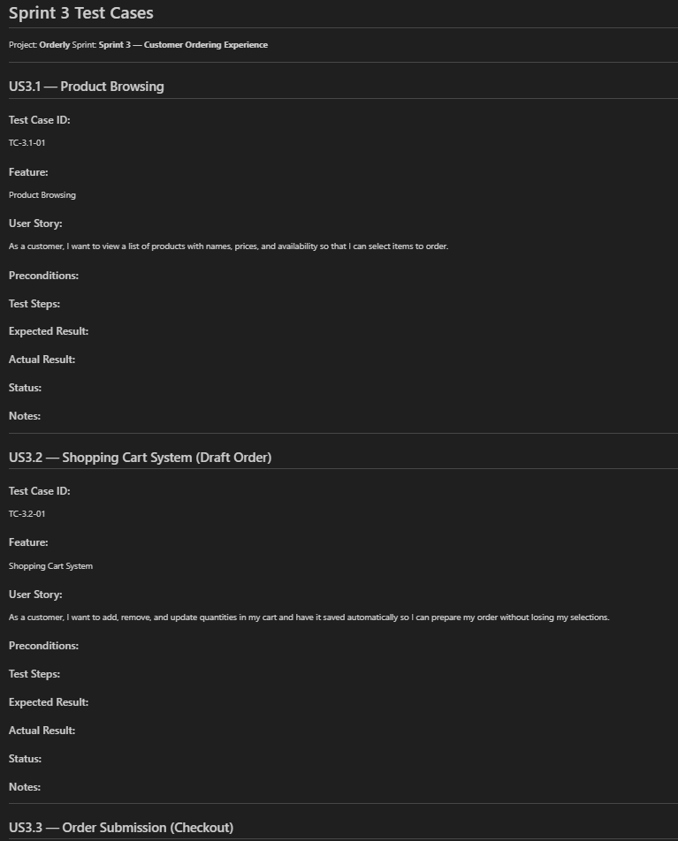
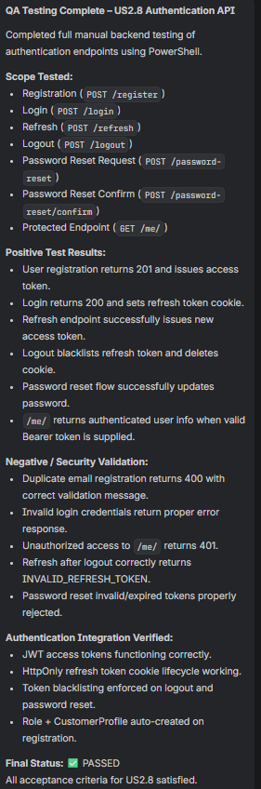
Kim — Writing Code
Kim concentrated on moving her feature work forward this sprint, completing several planned tasks and clearing blockers that had been slowing progress. She also partnered closely with teammates to review PRs and align on requirements for upcoming work.
She completed the stories.
Screenshot
